**Enroll a Non Samsung Device**

1. Install the free Intune Company Portal app from [Google Play](http://play.google.com/store/apps/details?id=com.microsoft.windowsintune.companyportal)
2. Open the Microsoft Intune Company Portal app
3. On the Company Portal **Welcome** screen, tap **Sign in**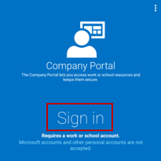
4. On the email address field type: [**.@nice.com**](mailto:.@nice.com) and click on **Sign In**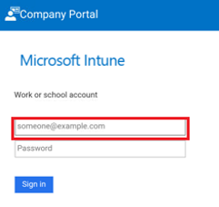
5. Enter your domain username and password -> **Logon**  
   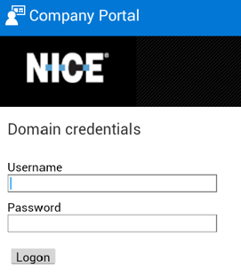
6. On the **Company Access Setup** screen, click **BEGIN** (The yellow triangles don't mean you've already got an error. Those icons indicate that there are still steps to be completed in the enrollment process)  
   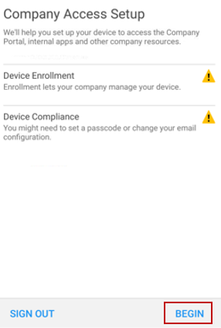
7. **Why enroll your device?** - what you can do when you enroll your device -> **CONTINUE**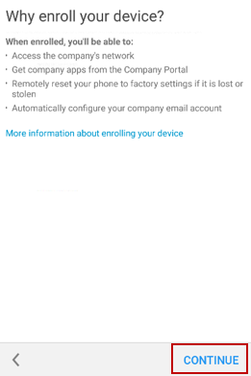
8. Review a list of what your IT admin can and can't see on your device, and then tap **CONTINUE**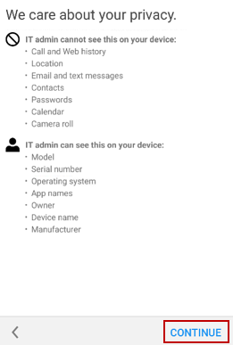
9. **What comes next** -> **ENROLL**  
   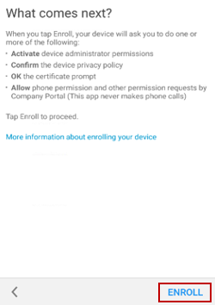
10. **Terms –** please read and click on **Accept**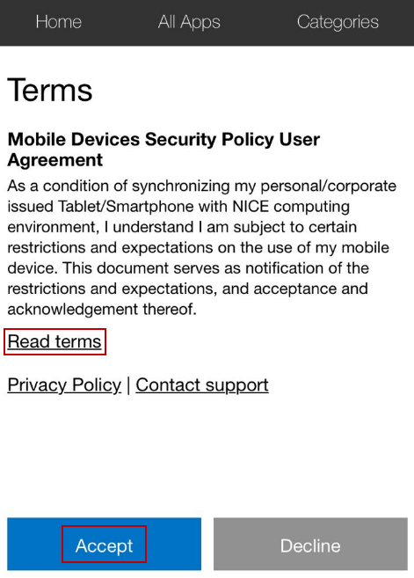
11. **Activate device administrator** -> **Activate**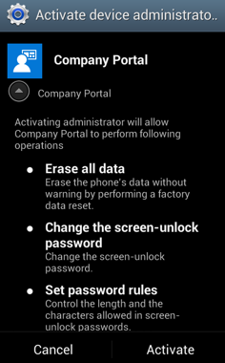
12. Please wait until enrolling your devic**e**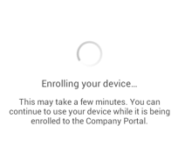
13. Tap **OK** to install the certificate  
    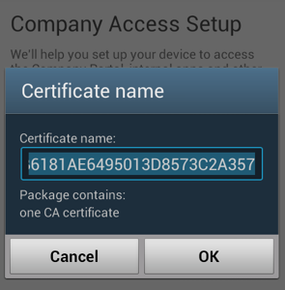
14. Follow the prompts to enter a PIN or password; If you already set up a PIN or password on this device, you won't see this screen or be required to enter a new PIN or password  
    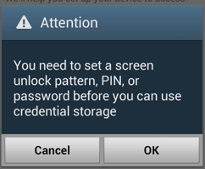
15. Once completed, you should see the following screen -> click on **Continue**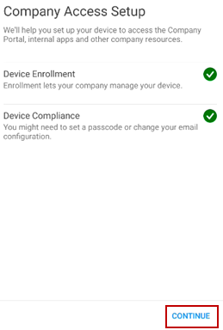
16. If your device is not compliance, you will receive the following screen. Click on the yellow triangle in order to view the error;   
    (1) For encryption issue, you should encrypt your device: **Settings** -> **Security** -> **Encrypt phone**(2) For passcode issue, you should set a PIN after power cycle the device **Settings** -> **Security** -> under **Encryption** -> **Require PIN to start device**  
    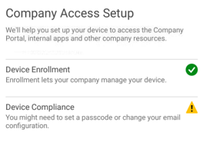
17. **Company Access Setup complete** screen -> tap **DONE** in order to finish  
    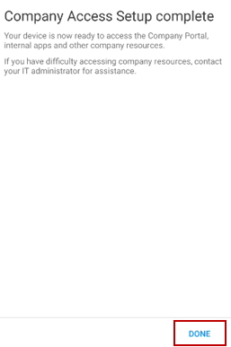
18. Open your native **email** app and configure the Exchange account manually, please use the below settings:  
    **Server:** mobileas.nice.com

**Domain: IL:** nice_systems | **NA:** NICEDEN | **EMEA:** RRL **User Name:** Domain username

**Password:** Domain password

1. **NOTE:** Once you see your emails, please remove Maas360:  
   Open the **Maas360** -> **Settings** -> click on **3 dots** (right corner) -> **remove MDM control ->** Delete the Maas360 application
2. **IMPORTANT: This step is relevant to the last date of the transition (according to the email you have received from NSC):**
3. On the next 3 hours, you will receive an email from **Nice Intune User Notifications** on your NICE mailbox
4. Open the email from your **mobile device** (if you don’t have access to your emails, please forward to your Gmail account) - If you receive more than 1 email notification, make sure to forward all
5. Click on **Get Started Now**
6. The Company Portal app will open  
   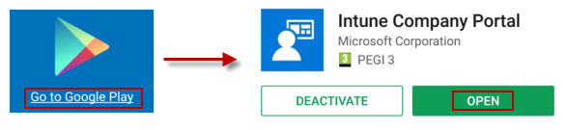
7. On the left corner click on the **flag**  
   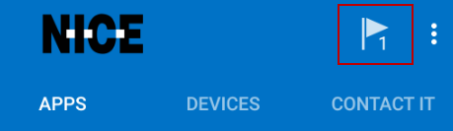
8. Click on the notification **“company access setup is incomplete”**  
   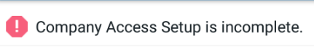
9. Click on **CONTINUE**  
   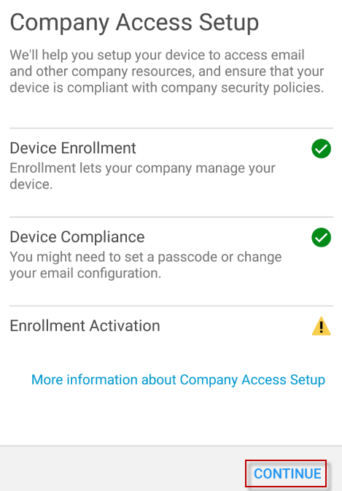
10. Make sure the three check marks should be green -> **DONE**  
    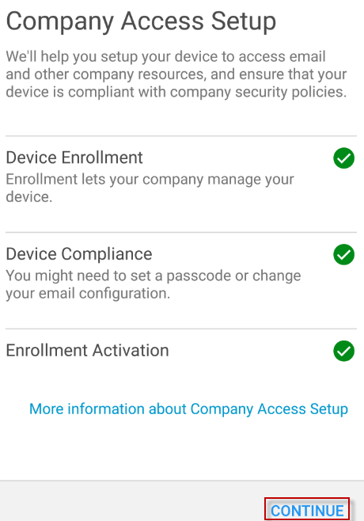
11. You should receive your emails in the next 15 minutes